***Assignment on Numpy***

1. Create a 1D array of numbers from 0 to 9.

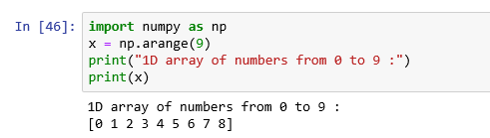

2. Create a 3×3 numpy array of all True’s

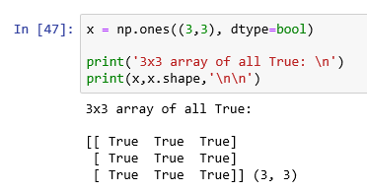

3. Given an array as input, print only odd numbers as output

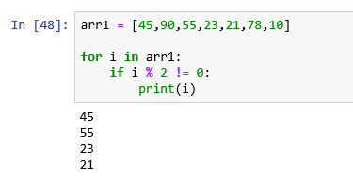

4. Replace all odd numbers in arr with -2

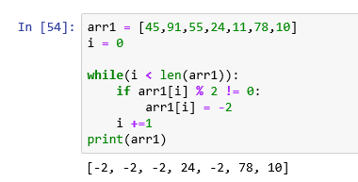

5. How to reshape an array?

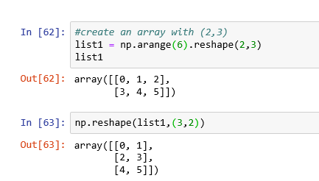

6. Convert a 1D array to a 2D array with 2 rows

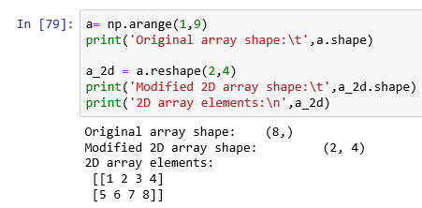

7. Given an array  a  = [1,2,3,4,5,6,7,8,9] , create  new array b from a such that b includes all odd numbers and 4 multiples.

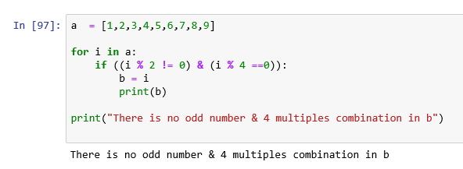

8. Given array, check if there are any null values and print them out.

9. How to replace all missing values with 0 in a numpy array?

10. How to find the count of each unique number in a NumPy array?

11. How to convert a numeric to a categorical (text) array?

12. Write a program to print all numbers between 99 and 299 which are either divisible by 5 or 7. Exclude the elements which are divisible by both.

13. Write a program to reverse an array and print (Don’t use inbuilt reverse functions)

